**AWS and API Setup**

## **Step 1** Create EC2 Machine

1. Select the EC2 Option from the services dropdown on your aws dashboard  
     
   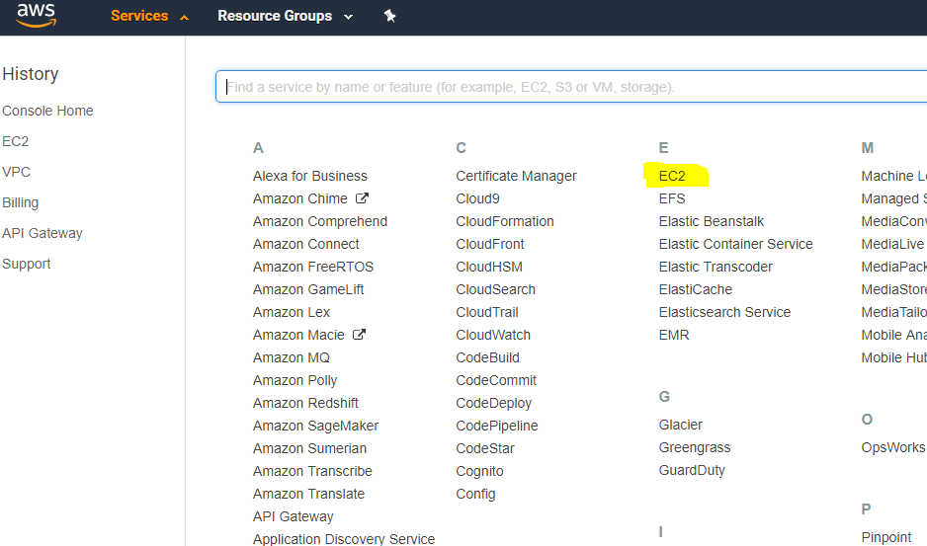
2. On the next screen of EC2 Dashboard, Select the Launch Instance option  
     
   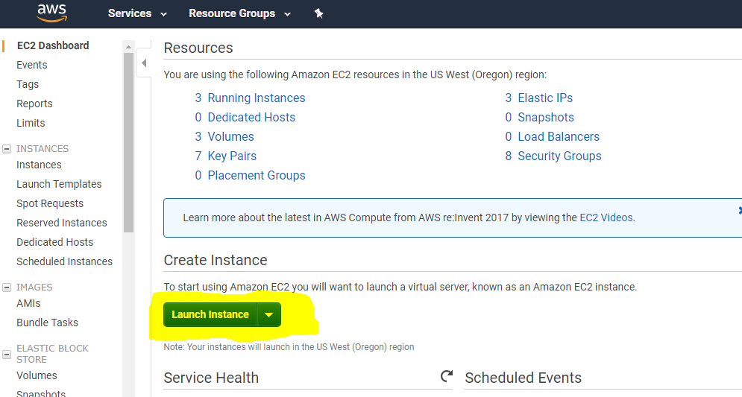
3. In this bootcamp we are using UBUNTU Server 16.04 Machine.   
     
   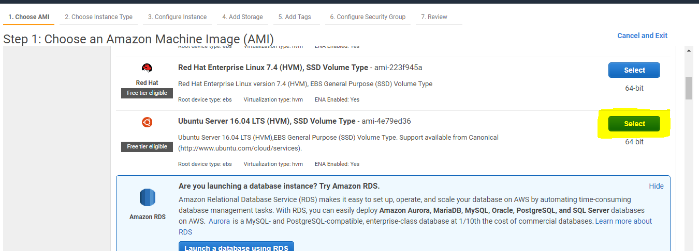
4. Now select the instance type - T2.Micro (It comes under the free tier label)  
     
   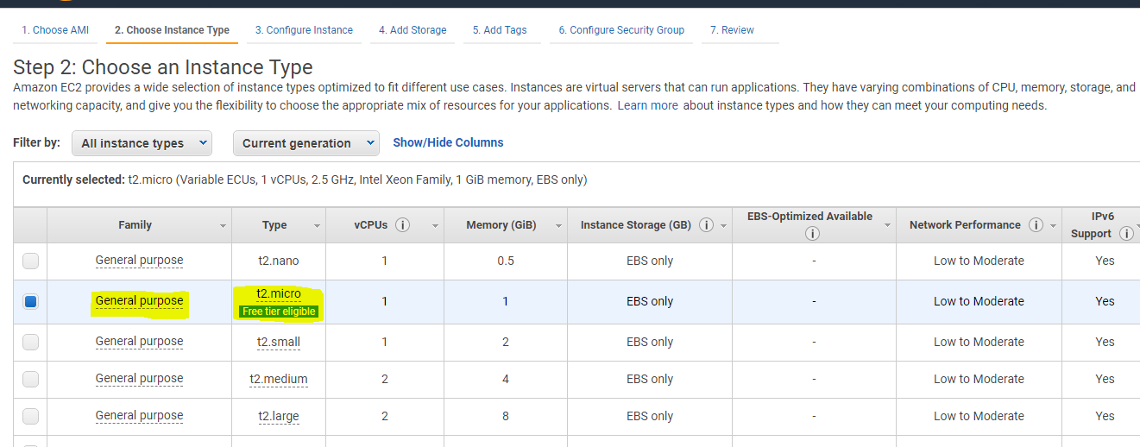
5. Enable auto assign IP – to open access from Internet  
     
   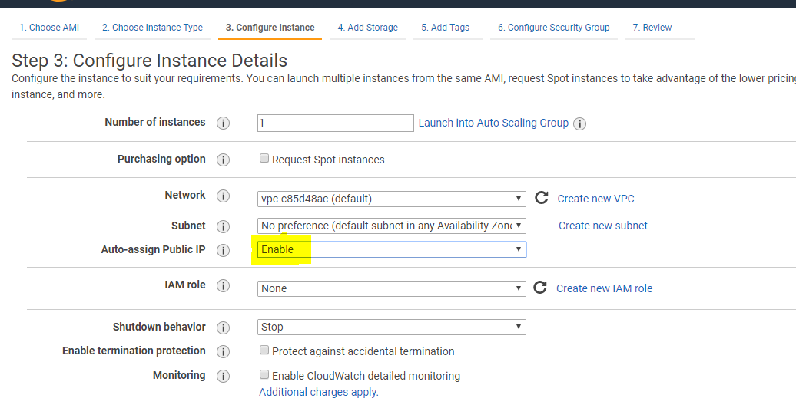
6. Set the default settings  
     
   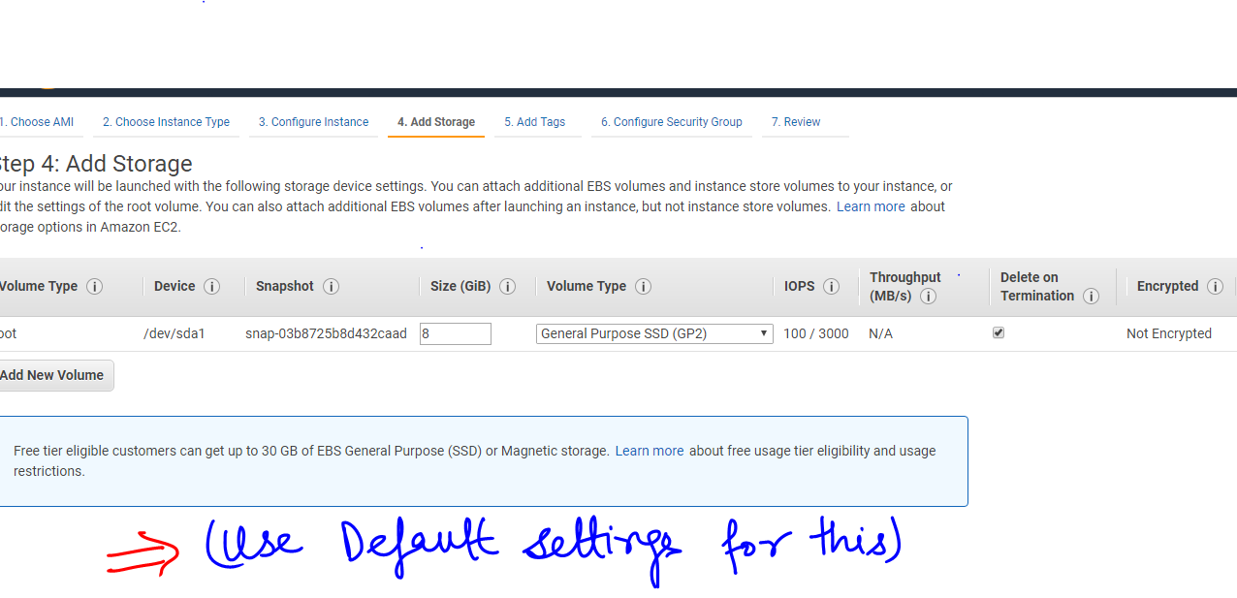
7. In next step “Add Tags” tab, Set the default settings  
     
   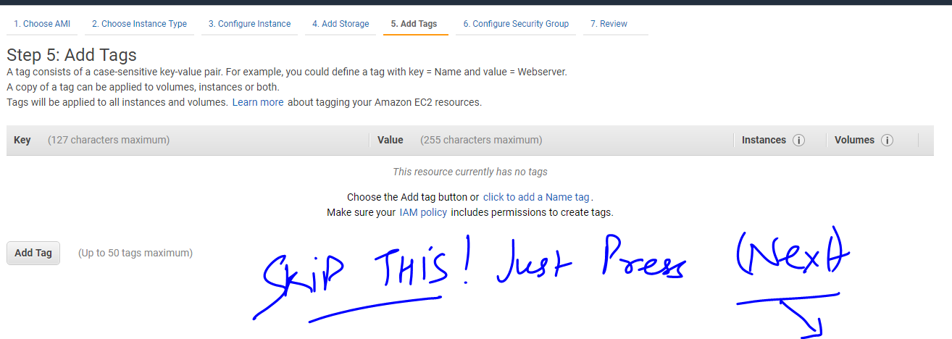
8. Configure the security groups as shown below  
     
   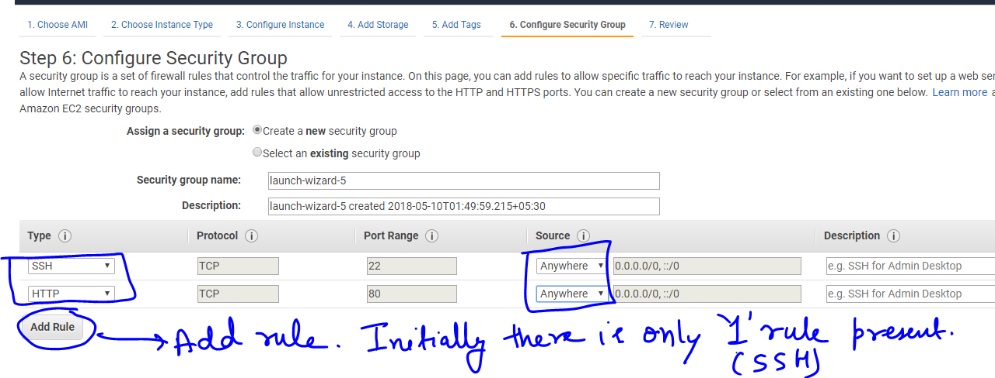
9. Save the .pem key to access the ec2 machine and then launch.  
     
   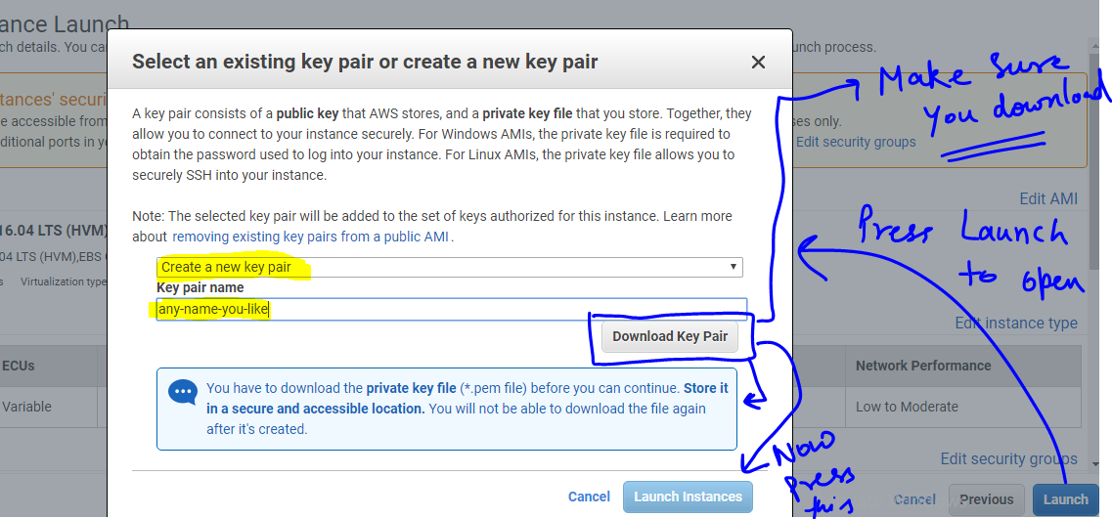
10. Set up an elastic ip for the instance. Elastic IP - remains same (whereas the ip which comes associated by default with the instance changes) when you stop the instance and thus gives you a better control over the instance. (Watch the below GIF to see how its done)  
      
    
11. Associate the above elastic IP Address with your ec2 instance.  
      
    

## **Step 2** Connect to instance using Putty

1. Convert key to .ppk from .pem
   1. Load in puttyGen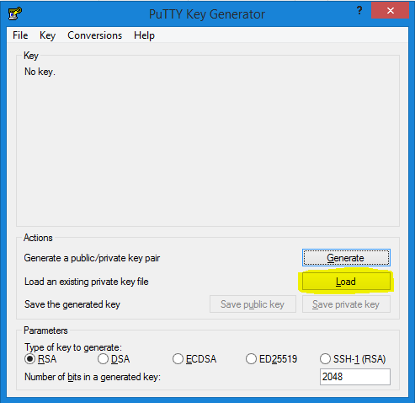
   2. Save Private Key  
      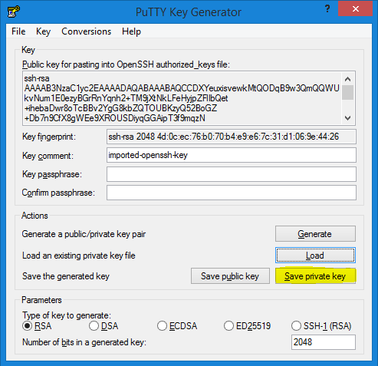
   3. Save Without Paraphrase  
      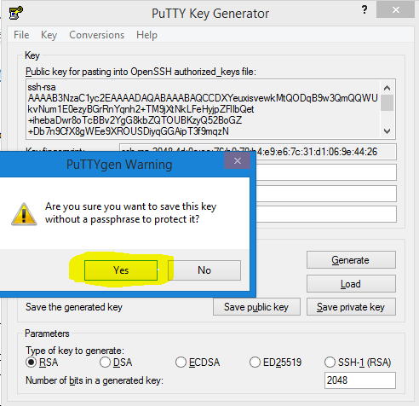
2. Setup Putty
   1. Enter the Hostname to the specified field. You will get the hostname from AWS EC2 Dashboard as shown below in the figure.  
      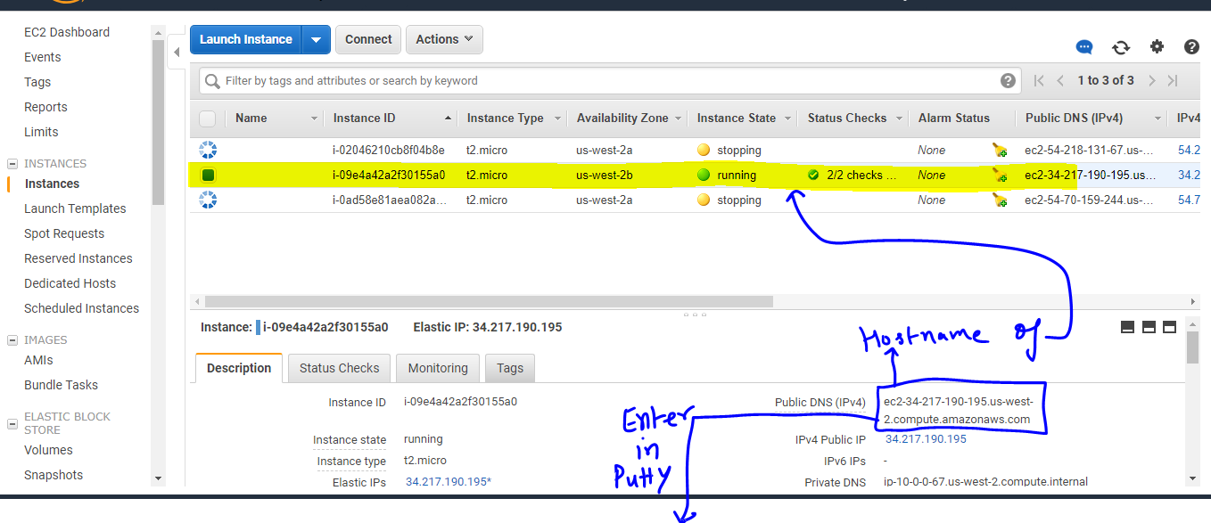  
      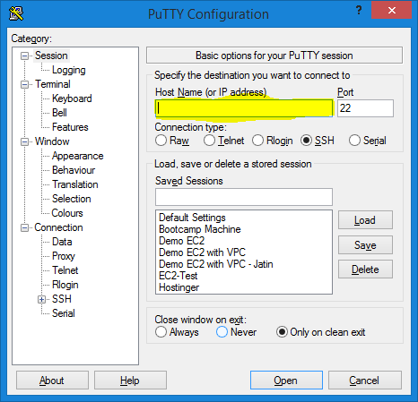
   2. Set the key in Putty in the field shown below  
      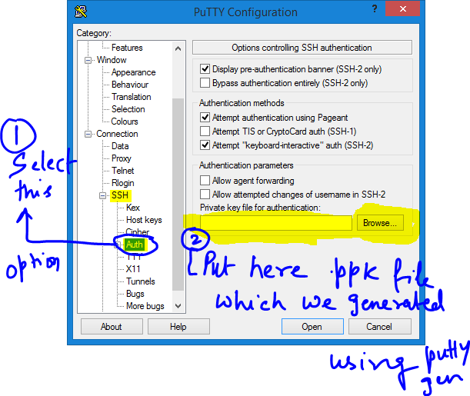
   3. Save Settings for this, so as to avoid this procedure again and again. (Note once you save your settings they will be available under saved sessions and you can select and load them.)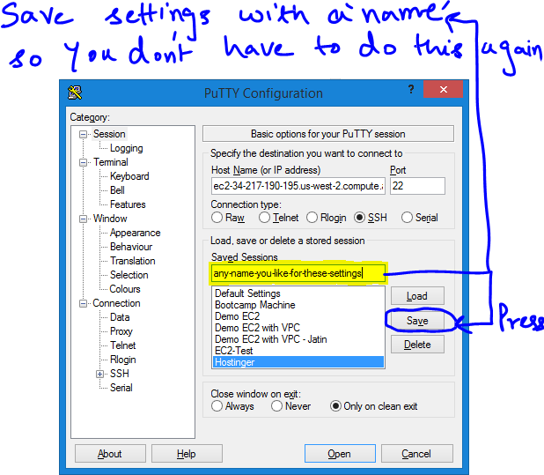
   4. Open Connection  
      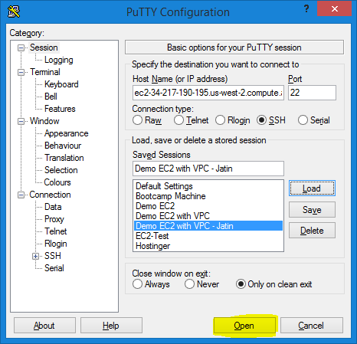

## **Step 3** Install Python and its dependencies

1) Install Python

a. sudo apt-get install python 2.7

2) Install development python dependencies

a. sudo apt-get install python-setuptools

Note : Run sudo apt-get update if you face any error like “Failed to fetch the resource”

b. sudo apt-get install python-dev

c. sudo apt-get install build essential

d. sudo apt-get install python-pip

3) Install development related libraries

a. pip install numpy scipy sklearn

b. sudo apt-get install python-pil

c. sudo apt-get install python-joblib

d. sudo apt-get install python-flask

e. To install opencv use this command  
 curl -s "https://raw.githubusercontent.com/arthurbeggs/scripts/master/install_apps/install_opencv2.sh" | bash

## **Step 4** Setup File Zilla for File Transfer

1) Add new site in site manager

2) Add ‘Amazon AWS key(.pem)’ in Edit->Settings->SFTP

## **Step 5** Configure Apache server on EC2

1) sudo apt-get Install apache2

2) sudo apt-get install libapache-mod-wsgi

Run “curl” => to => TEST => Everything is working

## **Step 6** Setting up the Flask app

1) Create Directory:

a. /var/www/FlaskApplications

2) Create another directory:

a. /var/www/Flaskapplications/SampleApp

3) Change Permissions:

a. sudo chown –R ubuntu:ubuntu /path/to

b. sudo chown –R 755 /path/to

4) Place the .conf file at

a. /etc/apache2/sites-available/SampleApp.conf

b. Change – hostname

5) Place the .wsgi file at

a. /var/www/FlaskApplications/

6) To test the setup, Place ‘demo.py’ file in /var/www/Flaskapplications/sampleApp/api/

7) Run

a. sudo a2enmod wsgi

b. sudo apachectl restart

c. sudo a2ensite sampleApp

8) Run

a. sudo service apache2 reload

b. sudo /etc/init.d/apache2 reload

c. sudo service apache2 restart

d. sudo /etc/init.d/apache2 reload